TINA-TI Simulation Task description

Project description：Please use TINA-TI software to design and simulate the functional circuit of DC-DC switching regulated power supply of the "TINA-TI Project".

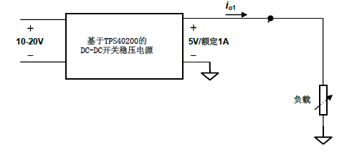

Figure 1. Schematic diagram of part of the voltage regulator source system

1. DC-DC Switched Regulated Power Module

Based on the TI TPS40200 chip, design and manufacture a DC-DC switching regulated power supply module circuit. The circuit can be adapted to DC input voltage of 10-20V, DC output voltage of 5V, with output current limiting protection function. Design a sampling sensor circuit for the output current, and the sampled sensor signal is amplified and output. Design a sampling circuit for the output voltage, the signal is adjusted and output.

The part of the circuit diagram of the regulator source can be referred to "Project file 2".

2. Basic circuit specifications

* Input voltage: can be adapted to DC 10-20V
* Rated output voltage: 5V DC

Absolute Voltage Accuracy：5V±3%

Voltage Adjustment Rate：Output Voltage Change Caused by Input Voltage Change

$$\frac{|Output voltage at 20V input−Output voltage at 10V input|}{Rated Output Voltage}≤0.5\% （pass）$$

Load Adjustment Rate: Output Voltage Change Caused by Load Change

$$\frac{|Output voltage at full load−Output Voltage at Half Load|}{Rated Output Voltage}≤0.5\% （pass）$$

* Output Voltage Ripple：Not greater than 100mVpp（pass）
* Rated Output Current：1A
* Allowable range of output overcurrent protection trigger value：1.1A~1.9A
* Power conversion efficiency (full load)：80% （pass）
* The output terminal shall be able to measure the voltage normally under no load

3. Project Requirement

Use TINA-TI software to complete the simulation circuit, and complete the following tasks according to the data manual of TPS40200/TLV2372 chip “TPS40200 Wide Input Range Non-Synchronous Voltage Mode Controller”:

* Complete the necessary parameter design of the circuit to achieve the basic technical indicators of the voltage regulator part of the project
* Can measure the output voltage, output voltage ripple and output current of the circuit；
* Write an experiment report

4. Some auxiliary materials

Link to download the program：

<https://www.ti.com/tool/EN/TINA-TI?keyMatch=TINA>

Chip data：

[https://www.ti.com.cn/product/cn/TPS40200?keyMatch=TPS40200#design-tools-simulation](https://www.ti.com.cn/product/cn/TPS40200?keyMatch=TPS40200" \l "design-tools-simulation)

[https://www.ti.com.cn/product/cn/TLV2372#design-tools-simulation](https://www.ti.com.cn/product/cn/TLV2372" \l "design-tools-simulation)